GE Aerospace Central Coating Laboratory Training Program

Thermal Spray Coatings
(Note: Training does not cover Diffusion Coatings)

March 11 to 15, 2024

IMR Test Labs – Singapore Pte Ltd, a Central Coating Laboratory (CCL) approved by GE Aerospace (GEA) is inviting you to register for the GE Aerospace Central Coating Laboratory Training Program for the period stated above.

Laboratory personnel are to undergo this training course to be certified prior to testing and evaluating GE Aerospace Thermal Spray Coatings.

A GE Aerospace (GEA) recognized certificate will be issued to participants who have successfully completed and passed the training program.

INSTRUCTOR
Suyin Chew
Lead Metallurgist
IMR Test Labs – Singapore Pte Ltd

VENUE
IMR Test Labs – Singapore Pte Ltd
30 Loyang Way
#03-16
Singapore 508769
Tel: +65 6592 5325
Fax: +65 6592 5236
- COURSE REGISTRATION & FEES

 | US$ | S$
Course Fee | 5,470.00 | 7,290.00
9% GST | 492.30 | 656.10
Total Cost (per student) | 5,962.30 | 7,946.10

Note(s):

- The cost per student is given in the table above. The 9% GST is only applicable to participants from Singapore registered companies.

- Participants are invited to register for the course by submitting the registration form in Annex 1.

- We would like to keep the class size to about 6 participants. Registrants beyond 6 will be placed on a Stand-by list. All registrants are on the Stand-by list until payment is received. IMR reserves the right to replace registrants that have not paid by 30 days prior to the course with another Stand-by registrant. Late registrations or replacements from the Stand-by list, if accepted, require payment in full immediately.

- A confirmation email and invoice will be sent to participants for the assigned course dates upon successful allocation of the training place.

- Payment is due in full no later than 30 days prior to the course date.

- Confirmed registrations cancelled more than 30 days prior to the course date are eligible for a full refund minus S$140 (US$100) processing charge.

- Confirmed registrations cancelled less than 30 days prior to the course date are liable for the full course charge with the option to apply the payment to a future course or transfer the registration to another student of the same company, less a 25% penalty to cover incurred course costs.

- Course no-shows are responsible for the full course charge without the option to apply the fee to a future course.

- In case of a replacement participant, IMR must be notified immediately via email to sudheer.prabhakaran@imrtest.com, along with submission of the registration form in Annex 1. The above notes are also applicable.

- If we do not get at least 4 participants for the course, the class may be cancelled. This cancellation and notification will be no later than 2 weeks before the start of the class. Please keep this in mind when making travel reservations.

- Participants who registered for a cancelled course will be notified via email and alternate course dates will be proposed for selection. Those who have paid may request for a full refund or choose to apply the fee for a future course.

- PAYMENT

Please note on the payment which course date you are attending and send payment to:

Via Wire Transfer
Beneficiary Bank Name: | HSBC Singapore
Beneficiary Bank Address: | 21 Collyer Quay #01-01, HSBC Building  Singapore 049320
Beneficiary Account Name: | IMR TEST LABS - SINGAPORE PTE. LTD.
Account Number
Paying in US$ | 260-751334-178
Paying in S$ | 047-209648-001
Swift Code | HSBC SGSG

Via Check
Make Check Payable To: | IMR Test Labs – Singapore Pte Ltd
Mail to: | IMR Test Labs – Singapore Pte Ltd  30 Loyang Way #03-16  Singapore 508769

- ACCOMODATION (FOR OVERSEAS PARTICIPANTS)

If you require accommodation, you may choose to stay at Grand Mercure Singapore Roxy hotel. Accommodation costs are not included in the course fees and will be at the participant’s cost. You may contact Shana, Sales Manager for reservations and mention that you are taking a course at
IMR Test Labs – Singapore Pte Ltd.

Tel: +65 6340 5608
Fax: +65 6440 1487
Mobile: + 65 98509494
Email: H3610-SL3@accor.com
www.grandmercureroxy.com.sg
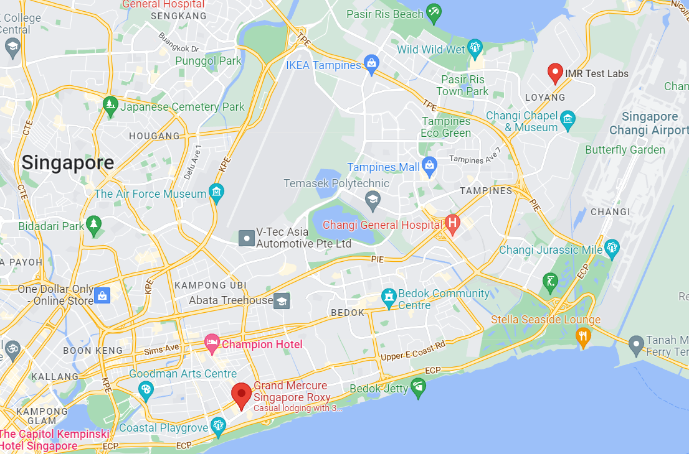
ANNEX 1

CENTRAL COATING LABORATORY TRAINING PROGRAM
THERMAL SPRAY COATINGS
(Note: Training does not cover Diffusion Coatings)

REGISTRATION FORM

March 11 to 15, 2024

PARTICIPANT INFORMATION
Full Name: |  |  | Preferred Name  (if any):
Job Title:
Email Address:
Personal Mobile:
Require Letter of Invite: | YES ☐ NO ☐ |  | Export License No.  (if applicable):
Dietary Restrictions: | YES ☐ NO ☐
 | If yes, explain:
COMPANY INFORMATION
GE Aerospace Supplier Code:
Company Name:
Company Address:
City: |  | Country: |  | Zip code:
Phone: |  | Alt. Phone: |  | Fax:
COMPANY FINANCE CONTACT INFORMATION
Full Name:
Email Address:
Contact No.:
ANNEX 1

CENTRAL COATING LABORATORY TRAINING PROGRAM

THERMAL SPRAY COATINGS
(Note: Training does not cover Diffusion Coatings)

PARTICIPANT EXPERIENCE & BACKGROUND INFORMATION

March 11 to 15, 2024

EXPERIENCE LEVEL
Hardness Test: | 1 2 3 4 5 6 7 8 9 10
Tensile Test: | 1 2 3 4 5 6 7 8 9 10
Erosion Test: | 1 2 3 4 5 6 7 8 9 10
Metallographic Preparation: | 1 2 3 4 5 6 7 8 9 10
Metallographic Evaluation: | 1 2 3 4 5 6 7 8 9 10
BACKGROUND INFORMATION
Education-Technical Courses/ Training:
Experience/ Background:
(Please also list experience other than coatings)
Coatings on which you have experience:
What coating families/ types does your company currently produce:
What do you hope to gain from attending the class:

ANNEX 2

CENTRAL COATING LABORATORY TRAINING PROGRAM
THERMAL SPRAY COATINGS
(Note: Training does not cover Diffusion Coatings)

 | Module | Approx. Time
Monday | Introduction  Processes & Applications  Specification & Hierarchy  Mechanical Testing (Hardness – Micro, Macro, Hoffman)  Mechanical-Hands On | 9:00 to 5:00
Tuesday | Mechanical Testing (Bond, Lap, Bend, Brush, Erosion)  Mechanical-Hands On  Metallography (Section, Clean, Mount)  Metallography-Hands On | 9:00 to 5:00
Wednesday | Metallography (Grinding & Polishing, Best Practices)  Metallography-Hands On  Metallography (Photostandards)  Metallography (Microscope)  Metallography (Evaluation Rules) | 9:00 to 5:00
Thursday | Metallography (Evaluation Rules)  Metallography-Hands On  Written Test Papers Due | 9:00 to 5:00
Friday | Practical Exam | 9:00 to 12:00
COURSE OUTLINE

Note(s):

- To ensure the safety of all participants and the class is not disrupted, participants are encouraged to wear a mask during the class and while in the lab.

- Lunch will be provided. Please indicate if there are any dietary restrictions in Annex 1 of the registration form.

- All written test papers are to be submitted for grading on the second last day of the course.

- In the event where participants wish to bring their own mounts for discussion, this must be indicated in the experience & background information in Annex 1 along with the coating families/ types.

